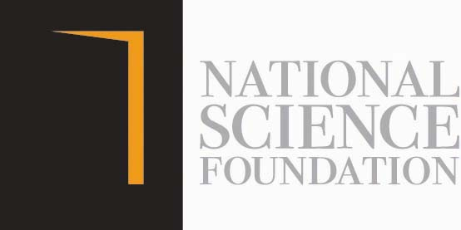
Kid Naturalist 2020

Application Form

- Name of the Student:
Birthday Gender: Male Female

Grade:
- Name of the parent/ guardian: Address:
Telephone: Home: Mobile:
Email address: Name and address of the school: ……………………………………………………………………………………………………..
………………………………………………..……………………………………………………Communication: Sinhala Tamil English

- Area selected by the student for observation ( eg: medicinal plant, specific bird, an insect, clouds etc.) ……………………………………………………………………………………….

I hereby certify that the above information given is true and correct.

……………………………...…………… …………………………………
Signature of the parent/ guardian Date

Note 1: After schools reopen, the certification as student's own work through the class teacher though Principal of the school should be submitted to the NSF with the original documents upon request of the NSF.

Note 2: If you wish to participate your kid for Kid Naturalist Competition organized by the NSF, please submit this application on or before 15 Aug 2020. Before completing the application, read the “Guidelines provided for parents and teachers “carefully. Please indicate “Kid Naturalist 2020” in the subject area of the email (maduka@nsf,gov.lk) or WhatsApp message (071-3216023).

